

MSc Data Science Project
7PAM2002-0509-2023
Department of Physics, Astronomy and Mathematics

DATA SCIENCE FINAL PROJECT REPORT

Project Title:
Predicting Stock Market Trends Using Machine Learning Models LSTM and Prophet

Student Name and SRN:
Susairaj Anthony - 22071718

Supervisor: Niall Miller
Date Submitted: 28/08/2024
Word Count: 11937
DECLARATION STATEMENT

This report is submitted in partial fulfilment of the requirement for the degree of Master of Science in Data Science at the University of Hertfordshire.
I have read the guidance to students on academic integrity, misconduct and plagiarism information at Assessment Offences and Academic Misconduct and understand the University process of dealing with suspected cases of academic misconduct and the possible penalties, which could include failing the project module or course.
I certify that the work submitted is my own and that any material derived or quoted from published or unpublished work of other persons has been duly acknowledged. (Ref. UPR AS/C/6.1, section 7 and UPR AS/C/5, section 3.6). I have not used chatGPT, or any other generative AI tool, to write the report or code (other than where declared or referenced).
I did not use human participants or undertake a survey in my MSc Project.

I hereby give permission for the report to be made available on module websites provided the source is acknowledged.

Student Name printed: Susairaj Anthony
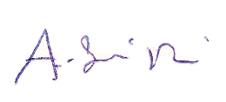
Student Name signature:

Student SRN number: 22071718

UNIVERSITY OF HERTFORDSHIRE
SCHOOL OF PHYSICS, ENGINEERING AND COMPUTER SCIENCE

ABSTRACT:
This research analyses the use of machine learning models to forecast trends in the stock market, concentrating on the stock prices of Barclays PLC between 2004 and 2024. The study evaluates the Prophet model and Long Short-Term Memory (LSTM) networks, two widely used options for time series forecasting. While the Prophet model was picked for its ability in modeling seasonality and long-term trends, the LSTM model was chosen for its capacity to capture sequential dependencies and short-term fluctuations. Yahoo Finance provided the study's data, which included daily stock prices and volume. With the model prepared for use the data received intensive preprocessing, which included addressing missing values, normalization, and feature engineering. Multiple bidirectional layers were used during training to optimize the LSTM model for both accuracy and generalization. The Prophet model was put into use to offer a more comprehensive outlook on potential pricing trends. The results show that whereas each model has advantages over the other, the LSTM model performs better in predicting short-term price fluctuations and has lower Root Mean Square Error (RMSE) values on both training and test datasets than the Prophet model. Though the LSTM model performs better, the Prophet model provides insightful information about seasonality and long-term trends. The analysis finds that while combining data from both models could result in a more thorough forecasting strategy, LSTM is the more successful model for short-term stock price prediction in unpredictable markets. The research also recognizes the shortcomings of both models, such as the difficulty in accounting for outside variables like geopolitical events and the possibility of overfitting due to computing complexity. Future studies may investigate hybrid models or the inclusion of external data sources to increase forecast accuracy.

Table of Contents

1. Introduction 6

2. Literature Review: Time Series Forecasting of Stock Prices 8

2.1 Theoretical Background 8

2.2 Research Questions 8

2.3 Long Short-Term Memory (LSTM) 9

2.4 Bidirectional LSTM 11

2.5 Prophet Model 12

2.6 Evaluation Metrics 13

2.7 Relevance in Practices 13

3. Methodology 14

3.1 Data Collection and Justification 14

3.2 Data Variables 14

3.3 Data Preprocessing 15

3.4 Feature Engineering 15

3.5 Data Validation 16

3.6 Model Selection and Justification 16

3.7 Hyper Parameters 16

3.8 Exploratory Data Analysis (EDA) 17

4. Result and discussion 18

4.1 Features of The Dataset 18

4.2 DataFrame Structure 19

4.3 A Comprehensive Analysis of Barclays Plc Stock Price Trends (2004–2024) 19

4.4 Simple Moving Averages 20

4.5 Evaluation of LSTM Model Performance Training & Validation Loss Analysis 21

4.6 LSTM Layers 22

4.7 LSTM Model Summary 23

4.8 Analysis of Model Predictions, Performance, And Generalization 24

4.9 Forecasting Future Stock Prices Using LSTM Model 25

4.10 Prophet Model for Time Series Forecasting in Stock Price Analysis 26

4.11 Comparison of Prophet and LSTM Models for Predicting Stock Prices 27

5. Conclusion 29

6. Limitations 29

7. Recommendation 29

8. References 30

9. Appendices 33
1. Introduction:
The Dutch East India Company's foundation in 1602 marked the beginning of stock markets. Almost all nations, developed or developing, have stock markets nowadays. The greatest markets in the world are found in the United Kingdom, United States, China, India, Germany, France, Japan, South Korea, Canada and the Netherlands. Maximizing profits has been the main objective of stock traders since 1602. To maximize profits, traders have tried a wide range of methods and created a wide range of tactics.
In the worlds of finance and technology, stock market prediction is a difficult but highly sought-after activity. The attraction is the possibility of forecasting changes in the market, which allows investors to make wise choices and maximize their profits (Li, Zhenglin et al., 2023). Modern computational approaches, especially in the field of machine learning, have enhanced traditional methods of stock market analysis, such as fundamental and technical analysis.
The volatility of stock prices is unpredictable because of a complex web of interconnected components (S. M. Idrees et al., 2019). Numerous elements, including fluctuations in global economic data, changes in unemployment rates, monetary policies of key nations, immigration laws, natural disasters, public health crises, and many others, can all play a role. Through detailed market analysis, all stock market participants seek to optimize profits and reduce risks. (Fama, 1965). The primary challenge lies in synthesizing these diverse pieces of information into a single, reliable model to make accurate predictions.
Predicting future earnings through stock price prediction is a difficult and demanding doing for companies, shareholders, and stock traders. The stock market is always in chaos, non-parametric, loud, and unpredictable system (Abu-Mostafa, 1996). It makes it more difficult to forecast the price in the future with accuracy and efficiency. A few methods have been proposed for addressing the challenging task of feature selection from the financial data in stock prediction.
Analysing past data, which can be unpredictable and complex, is often necessary to predict stock performance. Machine learning can be used to improve and accelerate this process. A large and detailed collection of historical data required to train an LSTM model can be found in the Yahoo Finance dataset for Barclays stock prices (S. Dubey, et al., 2022). This dataset contains trade volumes for a given time in addition to a range of financial metrics such as opening, closing, high, and low prices. These variables are crucial inputs for the predictive model because they show how the market reacts to different economic developments and investor mindsets (Ezepue, 2019).
As one of the world's oldest banks, Barclays has a long history and contributes significantly to global finance through its corporate, investment, retail, and wealth management activities. Because Barclays' stock is utilized as an indicator for the banking industry and the overall economy, investors and analysts maintain a close watch on the company (Barclays, n.d).

Barclays is a prominent worldwide provider of financial services, with its headquarters situated in London, UK. It is a part of the FTSE 100 Index, which trades with the London Stock Exchange (LSE) under the ticker symbol BARC and ranks the top 100 LSE-listed companies by market capitalization. Numerous factors, including as the state of the global economy overall, shifts in interest rates, changes in regulations, and the bank's financial success, all have an impact on Barclays' stock performance (Barclays, n.d).

Barclays' stock market is dynamic and subject to the influence of both external and internal variables, including shifts in the regulatory landscape and geopolitical events, as well as quarterly earnings announcements. Due to the bank's wide-ranging international operations, it is subject to different economic situations across different geographies, which may increase the volatility of its stock price. Overall, the complex connection between the governance of the market, alterations in regulations, the bank's strategic ambitions, and its operational success determines Barclays' performance in the stock market (Barclays, n.d).
Long Short-Term Memory networks are one of these methods that have become well-known due to their incredible ability for analysing time series data (S. Hochreiter and J. Schmidhuber, 1997). Recurrent neural networks of a particular sort called long short-term memory are excellent for scenarios where historical data is essential for predicting future results (Rumelhart, 1986). In the case of stock market prediction, when time periods in data are important, this feature is especially helpful. An LSTM model's deployment for stock market prediction might provide important insights that assist investors in spotting market patterns and developing strategy. By using the Yahoo Finance Barclays stock prices dataset, the model is trained on accurate and complete data, which improves the predictability of the results. The integration of advanced machine learning methods with solid financial data is a prime example of the most recent developments in financial analytics.
Facebook's Central Data Science department created PROPHET, a tool for forecasting on time series data. With its scalable design, PROPHET intends to offer an automated forecasting solution that streamlines the procedure and makes it usable by analysts of all stripes, including those with not much prior forecasting knowledge (Facebook, 2017).

Facebook claims that PROPHET performs best with time series that have numerous seasons of historical data and strong patterns of seasonality. Additionally, it is robust to trend fluctuations and outliers. PROPHET does not exhibit seasonality in our sample, but it still functions well. Because of its adaptability, analysts can use it for time series data that has undergone major changes without worrying about the data's fitness for predicting (Facebook, 2017).

The predictive model's performance might not be optimal due to the limited number of features used. On the other hand, the model could be complex and hard to understand if all the financial market's elements are established. Furthermore, the overlap of multiple parameters could lead to subpar model performance. To sum up, the combination of advanced machine learning methods like LSTM networks and the PROPHET model with reliable financial datasets like Yahoo Finance's is a big step forward for the field of financial analytics. It's important to recognize that these models have limits even if they provide useful tools for analysing market dynamics and projecting stock prices. Because of the stock market's complexity and the multitude of erratic and interrelated elements that impact it, no model can provide a 100% accuracy guarantee. As a result, while these predictive models can significantly improve investors' and analysts' ability to make decisions, they can only be utilized in conjunction with a more comprehensive plan that considers the risks and uncertainties that are a part of the financial markets. This all-encompassing strategy guarantees that forecasts are supported by genuine knowledge of market dynamics in addition to being based on data.
2. Literature Review: Time Series Forecasting of Stock Prices
Forecasting stock prices is an essential component of financial analysis that helps investors make wise choices. mainly, this literature review explores ways standard forecasting models like Facebook's Prophet and LSTM networks are applied to the prediction of Barclays stock prices. With the goal to gather financial data for modeling, the study covers various stages of the forecasting process, such as data pretreatment techniques that deal with outliers, missing values, and standardization. It also looks at training LSTM networks, which are very good at capturing temporal correlations, and utilizing Prophet, which effectively separates time series data into trends, seasonality, and holiday impacts. Furthermore, the review evaluates these models' forecasting performance by comparing their robustness and accuracy in predicting changes in stock prices, thereby providing insight into their usefulness in financial markets.
2.1 Theoretical Background:
Time series forecasting has improved considerably, moving from simple statistical techniques to more complex machine learning models. The Long Short-Term Memory network is a sort of recurrent neural network that has proven to be especially useful for processing sequential data. With the use of input, output, and forget gates, which enable the model can maintain and eliminate data over time as needed Long-term dependencies are understood by LSTMs by design. Because of its architecture, long short-term memory models are specifically well suited for complicated applications such as financial forecasting, where it is essential to comprehend seasonality, trends, and temporal dependencies.
However, Facebook's Prophet model provides an efficient equivalent for time series analysis, especially when handling data with substantial seasonal fluctuations, missing values, and outliers. By breaking out a time series into its essential elements trend, seasonality, and holiday effects Project provides unique perspectives on the underlying causes of the data. By modeling each component independently, this breakdown not just makes the model easier to understand but also makes it better at forecasting. Prophet is a well-liked option among clients that need to quickly extract insights from complicated time series data without requiring a lot of adjusting because of its adaptability and simplicity of use.
2.2 Research Questions:
- What impact does market volatility have on the stock price predictions made by the LSTM model?

- What effects do different financial indicators (e.g., RSI, moving averages, and trade volume) have on the precision of LSTM models used to predict the stock market?

- What are the limitations on LSTM models' ability to forecast changes in the stock market, and how may these limitations be overcome?

- How would data preprocessing techniques (e.g. normalization and handling missing values) influence the way LSTM models perform when making stock market predictions?
2.3 Long Short-Term Memory (LSTM):
In 1997, Sepp Hochreiter and Jürgen Schmidhuber presented the Long Short-Term Memory, a type of Recurrent Neural Network architecture. The model's ability to efficiently manage long-term dependencies is due to the gates that were included in the structure in order that control the information flow between cells. Because stock price data is sequential, the LSTM model's architecture was designed to handle this issue and make the model appropriate for time-series forecasting (S. Hochreiter and J. Schmidhuber, 1997).

Ad hoc structure and a high number of unclearly purposed components have been pointed up as limitations of the LSTM design. Because of this, it is uncertain if the LSTM is the optimal design, and it is possible that there are alternatives that are preferable. Data visualization is an attribute of LSTM models. The more you apply and utilize the model, the more accurate LSTM models can become. Consequently, accuracy improves, and error reduces with each epoch or iteration. It was also discovered that LSTM models could resolve the vanishing gradient problems (Hamayel Owda, 2021).
A different approach to the problem is taken by LSTM, which is made up of computational memory cells can store data over an extended period. These kinds of memory cells are highly accurate at predicting stock values. One drawback of this approach is that it can only achieve high accuracy with very big data sets. However, this is not a problem because stock data from websites such as Yahoo Finance is openly available and can go back over a decade in some circumstances (Gandhi et al., 2023).
LSTM incorporating recurrent neural networks have shown to be effective and flexible for a variety of sequential data processing problems. Because of their strong and adaptable architecture, they are excellent in capturing long-term temporal correlations.

Three gates - LSTM systems, the input, forget, and output gates regulate the memory cell.

- The input gate controls the data that is stored in the memory cell.
- The forget gate controls the data that is removed from the memory cell.
- The output gate controls the data that is extracted from the memory cell.

Figure:1 The neural network's Long Short-Term Memory architecture. (Based on Yan Diagrams)
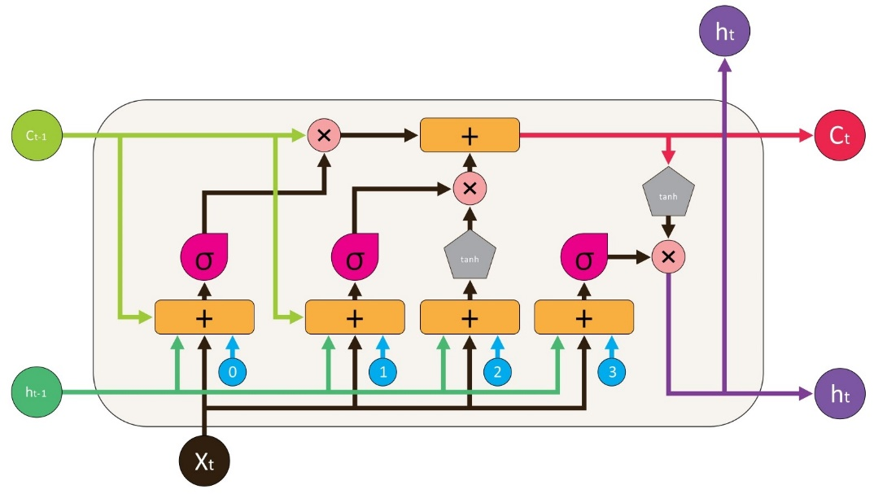
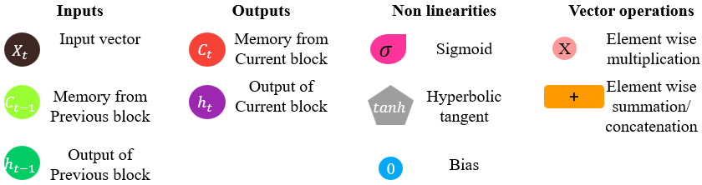

A Long Short-Term Memory unit performs using the following fundamental equations:
Forget Gate:
$f_{t}=σ(W_{f}​⋅[h_{t-1}​,x_{t}]+b_{f}​)$ (1)

The forget gate's activation vector $f_{t}$is calculated using the sigmoid function σ, which takes as input the weighted sum of the previous hidden state $h_{t-1}$​, the current input ​, and the bias term $b_{f},$all combined with the weight matrix $W_{f}$.
Input Gate:
$i_{t}​=σ\left(W_{i}​⋅\left[h_{t-1}​,x_{t}​\right]+b_{i}​\right)$ (2)
$$\tilde{C_{t}}=tanh(W_{C}​⋅[h_{t-1}​,x_{t}​]+b_{C}​)$$ (3)

The candidate cell state $\tilde{C_{t}}$, which is computed by applying the hyperbolic tangent function $tanh$ to the weighted sum of the previous hidden state and the current input using the weight matrices $W_{i}$ and $W_{C}$ along with the corresponding bias terms $b_{i}$ and $b_{C}$, determines how much of the current cell state will be added by the input gate's activation vector $i_{t}$.

Cell State Update:
$C_{t}​=f_{t}​⋅C_{t-1}​+i_{t}​​⋅\tilde{C_{t}}​$ (4)

Under the conditions of the LSTM network's forget gate and input gate processes, the updated cell state $C_{t}​$, is obtained by adding new data to the prior cell state $C_{t-1}​$.
Output Gate:
$o_{t}​=σ\left(W_{o}​⋅\left[h_{t-1}​,x_{t}​\right]+b_{o}​\right)$ (5)

$h_{t}​=o_{t}​⋅tanh(C_{t}​)$ (6)

The output gate's activation vector $o_{t}$ determines the current hidden state ​, which is calculated using the weight matrix $W_{o}​$and bias term $b_{o}$ applied to the combination of the previous hidden state and the current input in the LSTM network (Peng and Guo, 2022).

2.4 Bidirectional LSTM:
Recurrent neural networks that handle sequential data in both forward and backward directions are called bidirectional LSTMs. Because of this bidirectional method, Bi LSTM can identify longer-range dependencies in the data, surpassing the capabilities of traditional LSTMs that operate in only one direction (Schuster and Paliwal, 1997).

Figure:2 The structure of a bi-directional LSTM (Yildirim, 2018)
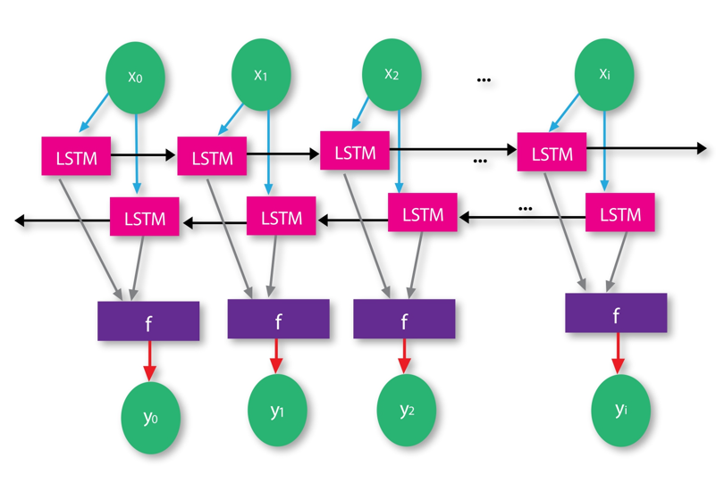

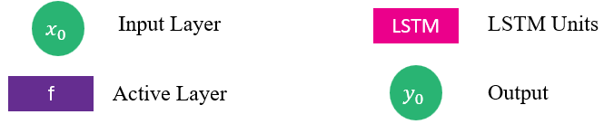

The hidden states from forward and backward directions are concatenated to form the final output of the Bi-LSTM
$${h_{t}}^{Bi-LSTM}​={{[h}_{t}}^{forward}​,{h_{t}}^{backward}]$$

Because of its combined hidden state, which incorporates data from the past and the future, the model is better equipped to capture context from both directions in the sequence.

2.5 Prophet Model:
Prophet was used because it could manage a variety of anomalies in time series data, including outliers and holidays. Because the time series was clearly divided down into trend, seasonal, and excess components, it was easier to figure out the underlying trends (Kaninde et al., 2022).

The PROPHET is easy to operate. The analysts have to generate a data frame with two columns in order to prepare their dataset. 'ds' (In datetime format the date stamp) and 'y' (the numerical forecasting data). The data frame is then fitted into an object that is constructed from the Prophet interface (Satrio et al., 2021). After that, analysts can create the forecast and indicate the preferred forecasting timeframe. The outcome has multiple columns, but "ds" and "yhat" are the most important ones. The predicted values of 'y' from the historical data frame are listed in the 'yhat' column. Plotting 'ds' and 'yhat' reveals characteristics like seasonality or future tendencies (Lu et al., 2023).

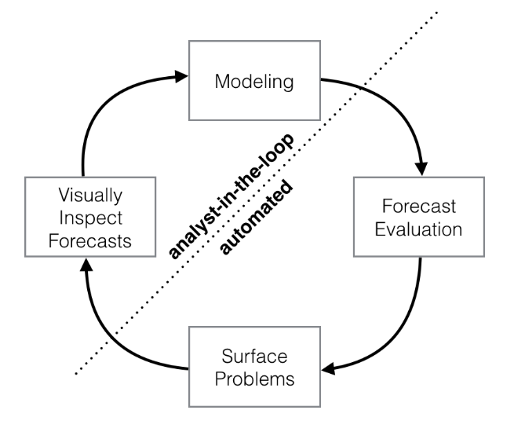
Figure 3: Prophet Model Structure (Source: Facebook, 2017)

The Facebook Prophet model for time series forecasting dived into four stages, as mentioned above:
- Modeling: Prophet's modeling process includes fitting the data to an object that captures trends, seasonality, and the effects of holidays.

- Forecast Evaluation: For evaluating the accuracy of forecasts, Prophet provides metrics like Root Mean Squared Error (RMSE). This step compares the actual values with the predicted values or yhat.

- Surface Problems: Any issues identified during evaluation, such as poor fit or unexpected anomalies, are surfaced. These problems could stem from data quality or incorrect seasonality detection.

- Visually Inspect Forecasts: Prophet makes it simple to plot predicted outcomes (yhat) over historical data, enabling analysts to check their accuracy and highlight areas that need more work.
The dotted line, "analyst-in-the-loop" versus "automated," shows that although Prophet automates a lot of processes, visual inspection and issue identification still require human monitoring. The forecasting process is improved by this blend of human participation and technology (Nair and Narayanan, 2022).

2.6 Evaluation Metrics
The Root Mean Squared Error (RMSE) was the main metric used to evaluate the model’s prediction performance. Root mean square error is a frequently used statistic in regression tasks, notably to evaluate the efficacy of forecasting models. Which is measured essentially the square root of the mean of the squared variances between the expected and actual values. Better prediction accuracy is indicated by a lower RMSE. The RMSE displays the extent in which the model's predictions match the actual data (Chai and Draxler, 2014).

"Accuracy" in the context of RMSE indicates the way the model's predictions fit the actual values. Higher accuracy is indicated by a smaller root mean square error, which denotes that the projected values closely match the actual values found in the data.

Root Mean Squared Error (RMSE): The mathematical explanation of the RMSE is as follows

RMSE =$\sqrt{\frac{1}{n}\sum_{i=1}^{n}{{\left(y_{i}-{\hat{y}}_{i}\right)}^{2}}}$

Where $n$is the total number of data, $y_{i}$ denotes the actual value at the i-th observation, ${\hat{y}}_{i}$ represents the predicted value at the i-th data. The term ${\left(y_{i}-{\hat{y}}_{i}\right)}^{2}$ is the squared variance between the actual and predicted values (Wang and Lu, 2018).

2.7 Relevance in Practices:
The combined use of machine learning and traditional models offers a comprehensive approach to forecasting, utilizing the strengths of each method. The findings have important effects for financial analysts and investors. Accurate stock price prediction can inform investment strategies, risk management, and portfolio optimization.

Further investigation may focus on the following areas:

- The integration of External Factors: Including news sentiment, macroeconomic indicators, and global financial indices could increase the model's accuracy.

- Hybrid Models: The predictions could be enhanced by incorporating LSTM with other neural network architectures or conventional models for the purpose to capture different aspects of the output.

- Real-Time Forecasting: Creating systems for the processing and forecasting of data in real-time could offer traders and investors timely insights.

The study shows the importance of thorough data preprocessing and the implementation of proper assessment measures by demonstrating the effectiveness of Prophet and LSTM networks in predicting stock prices. Combining these models provides an advanced knowledge of stock price fluctuations, which is crucial to wise financial decision-making.

3. Methodology:
I used Yahoo Finance, a well-known website and open-source library, as a financial analyst to compile the extensive dataset required for accurate stock price prediction. With respect to a variety of financial products, such as equities, bonds, currencies, and cryptocurrencies, it provides extensive access to both historical and current data. Users may carry out comprehensive market analysis, create prediction models, and make well-informed financial decisions because to this wide range of data coverage. The accessibility and user-friendly layout of Yahoo Finance, which serves both inexperienced and seasoned investors, is one of its main advantages. Every day open, high, low, close prices, trading volumes, and dividend data all essential for time series analysis are all compiled by the platform from a variety of sources to guarantee that users have access to current and reliable information.
3.1 Data Collection and Justification:
I collected and prepared the dataset needed to forecast Barclays stock prices using a significant and reliable data preparation technique. From 2004 to mid-2024, Yahoo Finance provided the daily closing prices that made up the dataset. This large dataset is ideal for assessing both short-term volatility and long-term trends since it offers a solid modeling base and covers a variety of market situations, including the COVID-19 pandemic and the 2008 financial crisis. Barclays PLC's importance in global finance and Yahoo Finance's trustworthiness as a data source guarantee that the dataset is relevant and dependable for accurate stock price forecasts (Botunac, Panjkota and Matetic, 2020).

3.2 Data Variables:
Several significant features providing a thorough picture of the stock's performance on the specific trading day are captured in the dataset used for stock price prediction. To fully understand market dynamics and provide accurate data to predictive models such as LSTM and Prophet, each of these variables is important. The variables include:
Table:1 Data Parameters and Denotations
Parameters used | Denotation
Date | The date corresponding to the stock price
Open | The share price at the opening of trade for that day
Close | The share price at the closing of trade for that day
High | The highest share price on the trading day
Low | The Lowest share price on the trading day
Volume | The total shares that traded throughout the trading session
These factors all provide important insights into the daily trading patterns of the firm. When combined, they provide a complete viewpoint on market conduct, which is necessary for reliable predictive models. In-depth study of stock price fluctuations is made possible by the variables "High," "Low," and "Volume," which improve forecasting and decision-making in the financial markets (PrasadDas and Padhy, 2012).

3.3 Data Preprocessing:
I discovered that an extensive preprocessing procedure was required to guarantee that my model could learn efficiently and produce accurate estimates, particularly considering the large duration and possible gaps or inconsistencies in the data.

Managing Missing Values: Preprocessing the data included addressing missing values as a crucial step. Gaps in time series can interfere with the model's capacity to identify patterns. A simple method to stay away from this to substitute the average of the available data points for any missing "Close" values, I used a Simple Imputer. This method guaranteed a full dataset for the model while maintaining the integrity of the time series. To ensure continuity, the procedure also included resetting the data index and applying the imputer regularly to properly handle missing data (Jancy et al., 2024).
Normalization: Normalization was the next preprocessing step after I addressed the missing data. The large value variation in financial time series data may pose a challenge to machine learning models, particularly neural networks. The data was normalized to a standard range, usually between 0 and 1, using MinMaxScaler. For all input features to be on the same scale, this step is crucial, which will accelerate training convergence and improve model performance (Nabipour et al., 2020).
Data Cleaning: General data cleaning procedures were used by me to make sure the dataset was prepared for analysis, in addition to handling missing values and normalization. I deleted any null values that remained after imputation to prevent any problems with residual data quality and reset the data index to preserve the proper temporal sequence. There was less chance of adding biases or noise to the model due to my diligent data cleansing.
3.4 Feature Engineering:
Technical Indicators: I created Simple Moving Averages (SMAs) comprising multiple time intervals (100-day, 200-day SMAs) based on current financial measures to improve the dataset. These indicators provided the model with insights into possible buy or sell signals and helped smooth out short-term shifts while highlighting longer-term patterns. By including these technical indicators, I made it much easier for the model to identify patterns and trends that may not be immediately visible when using raw data alone (Khand, Anand, and Qureshi, 2020).
Lagged Features: The intent of generating lag versions of important variables, such as the "Close" price, is to bring historical context to the dataset. For example, 'Close' values from one or five days ago can be included as extra features. Time series prediction depends heavily on the model's ability to understand how past results affect future stock prices, which is made possible by these lagged properties. The model's ability to forecast future prices based on historical data is improved by the addition of lag characteristics, which capture temporal dependencies.

3.5 Data Validation:
Checks for Consistency: I placed the dataset under checks to ensure data integrity after preprocessing. This included checking for duplicate entries, making sure the data types were proper, and ensuring that no null values were retained. For the model to continue receiving accurate and clean inputs, consistency checks were essential. To avoid biases or mistakes during model training, I quickly fixed any abnormalities or inconsistencies.
Data Splitting: I analysed the dataset and divided it into training and testing sets, with most of the dataset being utilized for training and the remaining portion reserved for testing. The most recent data was used for testing, while the oldest data was used for training. I typically perform this split historically so that the model is assessed based on its capacity to forecast future stock values in a real-world situation. By using a split ratio, such as 80% for training and 20% for testing, I balanced effective model training with enough data for accurate performance evaluation.
The dataset is made ready for machine learning models by the thorough data beforehand procedures, which include feature engineering, data validation, normalization, and management of missing information. By converting unstructured financial data into a clean, organized, and feature-rich dataset, these procedures improve the model's capacity to learn and provide precise stock price predictions. Accurate and understandable forecasts require proper data preprocessing, particularly in the complicated and volatile world of financial markets.
3.6 Model Selection and Justification:
The LSTM model can learn and recall long-term dependencies, it is especially well-suited for time series data and is perfect for capturing the sequential character of stock price data. Its ability to learn from both historical and future data is enhanced by the bidirectional LSTM, which I used to help the model anticipate complicated patterns. LSTM models are perfect for forecasting the price of stocks for the following day based on past trends since they are especially good at capturing short-term price movements. But for LSTMs to function successfully, they need a lot of data and are computationally demanding. If regularized improperly, they can also be subject to overfitting.
I selected the Prophet model for this project due to its ability to handle missing data and time series data with strong seasonal trends. Prophet is a useful tool for identifying long-term trends and seasonality in stock prices because it remains easy to learn and very interpretable. It provides a more comprehensive picture of potential future price changes by accurately modeling patterns and seasonality. Prophet, on the other hand, may not be as good at capturing short-term changes as LSTM, and it assumes that future seasonal patterns will follow historical trends, which may not always hold true in erratic markets.
3.7 Hyper Parameters:
The LSTM model I used employs bidirectional LSTM layers, which effectively double the parameters to capture both past and future dependencies in the data. I set the number of units in the LSTM layers at 50. To avoid overfitting, I implemented a random dropout rate of 0.2 throughout these layers during training, which removes a fraction of the connections. The model predicts the price for the following day by using a time step of 100, which means it looks back 100 days. It is trained using the Adam optimizer for effective and adaptable learning across 100 epochs with a batch size of 32. To maximize the accuracy of the model's predictions, the Mean Squared Error loss function is used. It does this by minimizing the average squared difference between the predicted and actual values.
3.8 Exploratory Data Analysis (EDA):
When analysing time series data, like stock prices, I find that exploratory data analysis with an emphasis on a line plot works very well. Visualizing the evolution of variables such as 'Open,' 'Close,' 'High,' 'Low,' and 'Volume' over time may be done easily and clearly with line graphs. By plotting these variables on a timeline, I can easily spot patterns in the data, such as upward or downward swings in stock prices, as well as any cyclical or seasonal patterns. Additionally useful for identifying anomalies or outliers, line charts can highlight unexpected price spikes or dips, as well as defects in collecting information or abnormal market events (Raubitzek and Neubauer, 2022).
The process I described for setting up and forecasting Barclays stock prices demonstrates a thorough approach to financial time series research. My method ensures that a variety of important market data, from daily prices to trading volumes, is carefully gathered and prepared using Yahoo Finance as a reliable data source. Preprocessing techniques such as mean imputation for handling missing values and MinMaxScaler for normalizing data show a careful approach to preserving data integrity and guaranteeing machine learning model compatibility. Additionally, I used technical indicators and lag features to further enrich the dataset, providing the model with data that captures both short- and long-term trends. Especially in the intricate and turbulent financial markets, this thorough planning provides a solid basis for accurate stock price forecasts (Patwal and Srivastava, 2023).
Table:2 Data Parameters and Preprocessing Techniques
Parameters used | Data Type | Preprocessing Techniques
Date | DateTime | Conversion to DateTime format
Open | Float | Normalized using MinMaxScaler
Close | Float | Imputation of missing values; Normalized
High | Float | Normalized using MinMaxScaler
Low | Float | Normalized using MinMaxScaler
Volume | Integer | Normalized using MinMaxScaler

This methodology, in summary, highlights the significance of feature engineering and thorough data pretreatment in financial modeling. My approach not only prepares the data for efficient model training but also enhances the predictive capability of models such as LSTM and Prophet by removing potential inconsistencies and adding valuable features to the dataset. This methodology is a strong tool for financial analysts, investors, and researchers looking to make informed stock market judgments since it handles data in a methodical manner from collection to validation, ensuring that the predictions that are produced are both reliable and beneficial (Alsuhaibani and Kryzanowski, 2000).
4. Result and discussion:
The process of analysing Barclays PLC stock begins with an intensive data collection and preprocessing step, ensuring the dataset's completeness and accuracy. Simple Moving Averages (SMAs) with 100- and 200-day periods are computed to capture long-term price trends. These SMAs offer insights into market sentiment and possible levels of support and resistance. Using its capacity to handle sequential data and long-term dependency, an LSTM model is trained to estimate future prices after the data has been divided into training and testing sets. Root mean square error provides a clear measure of the model's prediction performance and is used to assess the model's correctness. Simultaneously, Facebook utilizes its Prophet algorithm to forecast future stock values through the identification of seasonal patterns and underlying trends; the outcomes are displayed alongside real historical data. It is clear from comparing the LSTM and Prophet models that they complement each other's strong points. While Prophet is better at capturing seasonality and long-term patterns, LSTM is better at making short-term forecasts since it is responsive to recent price changes. With a more complete forecast, this dual-model method improves predictive accuracy and paves the way for future developments with hybrid modeling techniques that can include other variables like economic or market indicators.

4.1 Features of the Dataset:
The table below shows a sample of Barclays PLC's stock market data, including important details for every trading day between January 1, 2004, and June 28, 2024. With many columns providing details on the stock's performance, each row relates to a certain date. While the "Open" column displays the opening price of the stock at which trading started once the market began, the "Date" column denotes the trading day. The stock's highest and lowest prices on that day are shown in the "High" and "Low" columns, respectively. The closing trading price at the time the market closed is shown in the "Close" column. In addition, the closing price adjusted for stock splits, dividends, and new stock deliveries appears in the "Adj Close" column, which gives a more realistic picture of the stock's actual value. The "Volume" column displays the total amount of shares transferred on a certain day on January 7, 2004, for example, 45,080,811 shares were traded. This dataset makes it possible to analyse daily changes in stock prices, market trends, and investor actions throughout the given time frame.
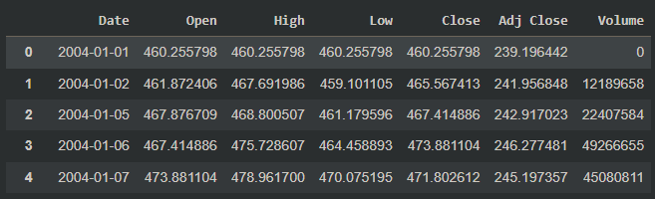
Figure 4: The above data extracted from the code

4.2 DataFrame Structure:
The dataset's structure and content are thoroughly summarized in the DataFrame overview. It is shown to include 5,192 rows, each uniquely indexed between 0 and 5,191, and is arranged into 7 different columns which is date, open, high, low, close, adj close, and volume. There are exactly 5,192 non-null entries in each column, showing that the dataset is full and free of missing data points. This is important because it guarantees the accuracy and dependability of any analysis or model that makes use of the data.

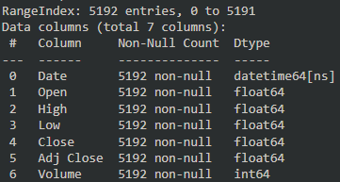
Figure 5: The above data extracted from the code

The Open, High, Low, Close, and Adj Close columns, all of which are of the float64 data type, store numerical values with floating-point precision, representing various price points of the stock on a given trading day. The Date column, formatted as datetime64[ns], stores date and time information with high precision, making it particularly useful for time-series analysis. The volume column, which is of the int64 data type, shows how many shares were exchanged overall on a given day. A high trading volume might be a sign of both possible market instability and great investor interest. All things considered, the dataset is well-suited for financial analysis, with all required fields filled in and data types appropriately assigned. This improves the accuracy of any predictive models or analytical techniques that are used on it.

4.3 A Comprehensive Analysis of Barclays PLC Stock Price Trends (2004–2024):
The historical closing prices of Barclays PLC stock from 2004 to 2024 are shown in the chart named "Barclays Stock Price Analysis". The time period which runs from 2004 to mid-2024 is displayed on the x-axis, while the stock prices, which range from roughly 0 to over 700, are displayed on the y-axis. The stock's closing price on each trading day appears on the blue line graph, which over time reveals important trends. The stock price increased significantly between 2004 and 2007, reaching a high of over 700. However, in 2008, in parallel with the world financial crisis, there was a severe downturn, with the price falling to less than 100. Following the crisis, there are times when the stock recovers and fluctuates, but starting in 2012, it settles between 100 and 300. Although there has been some increase in price in recent years, it is still much below its high before the crisis. The legend located in the upper right corner verifies that the blue line depicts the closing price of the stock, so providing an effective visual representation of the stock's long-term performance and the influence of significant economic events on its valuation.

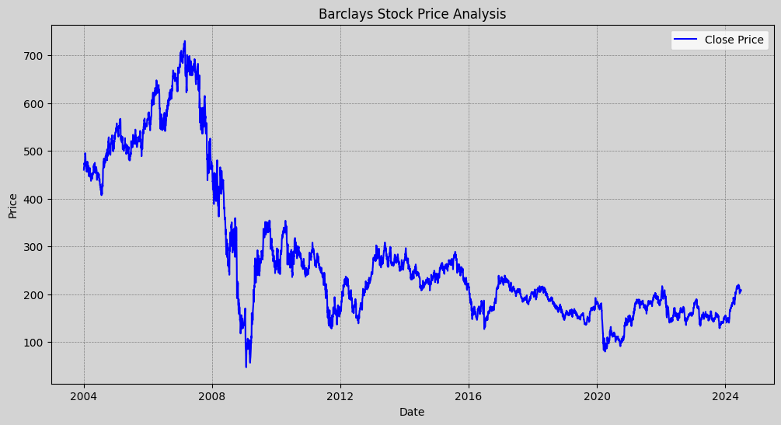
Figure 6: Barclays Stock Prices using Close Price

Barclays PLC (ticker: BARC.L) stock price analysis starts with a full data pretreatment step which tackles missing information to ensure the dataset's quality. The 100-day and 200-day Simple Moving Averages (SMAs), two important technical indicators, are then computed. By giving a smoothed perspective of fluctuations in prices and enabling in the identification of possible regions of support and resistance, these SMAs are essential for capturing the longer-term price trends of the stock. These moving averages provide the study additional depth and provide insights into the underlying market sentiment and momentum, both of which are critical for producing accurate predictions (Tiwari et al., 2023).

4.4 Simple Moving Averages:
The 200-day and 100-day Simple Moving Averages (SMAs) are two important technical indicators that are superimposed on the closing prices of Barclays PLC's shares from 2004 to 2024. The actual daily closing prices are represented by the light blue line, which displays the daily changes in the stock's value. By averaging closing prices over the previous 100 days, the green dashed line (also known as the 100-day SMA) offers insight into shorter-term patterns and responds more quickly to recent price fluctuations. By averaging the previous 200 days, the red dashed line (200-day SMA) provides a more refined depiction of longer-term trends that are less impacted by short-term volatility.

While the 200-day SMA, with its broader scope, is invaluable for judging the general market trend and long-term momentum, the 100-day SMA is especially beneficial for finding shorter-term opportunities and trends due to its greater responsiveness to recent price changes. With the help of this dual method, analysis can be complex, and decision-making can be enhanced by considering short-term changes in the context of longer-term patterns. Additionally, the capacity to recognize significant turning moments, like extended growth or drop periods, is improved by visualizing these SMAs in conjunction with historical price data. This skill is crucial for strategic investment planning. By incorporating these technical indications into their analysis, investors can maximize their potential profits by better anticipating market moves and modifying their strategy accordingly.

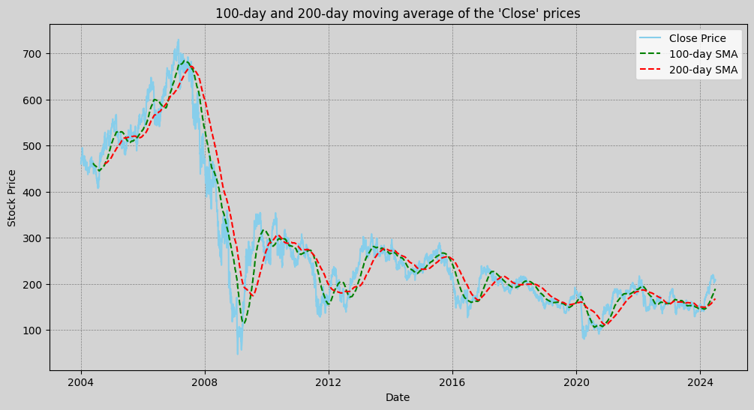

Figure 7: 100 Day and 200 Day Simple Moving Average using Close Price

While both SMAs often track the direction of the actual stock price, the 200-day SMA delivers a more comprehensive picture of market sentiment as the 100-day SMA is more sensitive. Both the actual price and the SMAs reflect significant events, like the 2008 financial crisis, but the SMAs soften the quick drops and produce a more readable trendline. The SMA crossover points can be used as crucial technical indicators. For example, an upward trend may be indicated if the 100-day SMA crosses above the 200-day SMA, while a negative trend may be indicated if it crosses below. Overall, by reducing daily moves and highlighting both short and long-term trends, this chart helps in the analysis of the stock's performance and is a useful tool for spotting possible buy or sell signals as well as understanding the movements of the stock over time.

4.5 Evaluation of LSTM Model Performance Through Training and Validation Loss Analysis:
Most of the data is utilized to train the model to find historical trends for the stock after it has been pre-processed and divided into training and testing sets. Long Short-Term Memory types are useful because they can handle sequential data and long-term dependencies. The LSTM model consists of many layers, including bidirectional LSTM layers that help recognize patterns both forward and backward. Once the model has been trained, its performance is evaluated using the Root Mean Squared Error, which calculates the difference between the actual and predicted stock values. This provides a clear picture of the accuracy of the model on the testing and training datasets.
The following figure provides a clear visual representation of the validation and training loss curve for a machine learning model over 100 epochs. The y-axis shows the loss, which is a measurement of the model's oversight, and the x-axis shows the number of epochs, with each epoch being a full run through the training dataset. The training loss is shown by the blue line, which begins high to reflect the model's early prediction errors. But as training continues, this loss rapidly drops, particularly in the first 20 epochs, suggesting that the model is picking up new skills and becoming more accurate. The training loss stabilizes after these early epochs, indicating that the model is improving its learning, but more slowly.
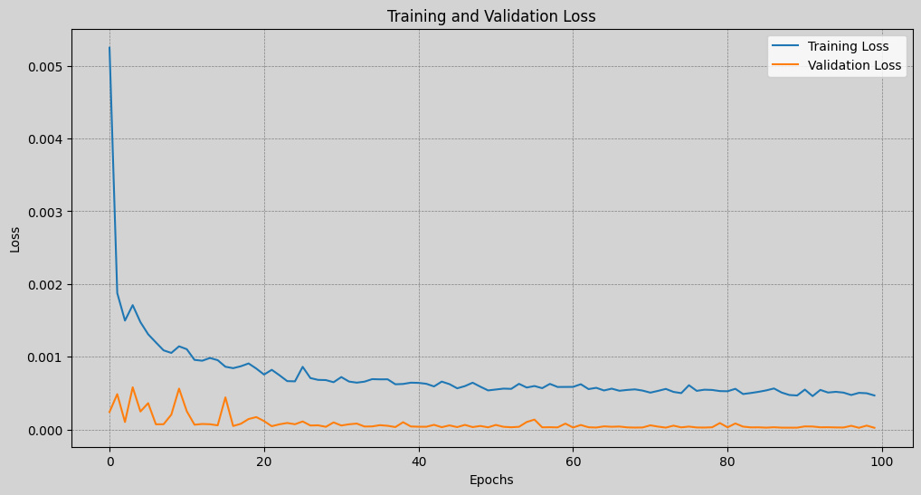
Figure 8: Training and Validation loss
The model's effectiveness with anonymous data during training is evaluated using the validation loss, which is represented by the orange line on the graph. Additionally, the validation loss starts lower than the training loss and varies very little during the 100 epochs. Stability indicates that the model is not overfit to the training set, which means it is learning patterns that transfer well to new, untested data rather than just remembering the training set by memory.
Comprehension of the model's performance depends on the relationship between the validation and training losses. As the model consistently performs on the training and validation datasets, there is high generalization, as indicated by the narrow distance between these two losses. The model retains its performance on unknown data while it keeps learning and adapting throughout training, as further evidenced by the validation loss's stability over time. A well-trained model that is probably going to perform well in real-world circumstances is indicated by this balance of training and validation losses.
4.6 LSTM Layers:
Bidirectional Layers: This layer, known as a Bidirectional LSTM layer, processes incoming data both forward and backward in order to more fully capture data dependencies.
- Bidirectional Layer_1: The model starts with a 50-unit Bidirectional LSTM layer that processes the input data both forward and backward to more effectively identify patterns in the data. The (return_sequences=True) guarantees that, this layer generates a sequence, which is required for LSTM layers that come after it. A Dropout layer with a 0.2 rate follows, removing 20% of the connections during training to avoid overfitting.
- Bidirectional Layer_2: Afterwards, there is a 50-unit Bidirectional LSTM layer with return_sequences =True, and a Dropout layer.
- Bidirectional Layer_3: The addition of a third Bidirectional LSTM layer results in the output of a single vector rather than a sequence because it does not return any sequences (return_sequences=False). To preserve regularization across the network, a Dropout layer comes after this last LSTM layer.
Dense Output Layer: A Dense layer with one unit at the end of the model generates a single output value, making it perfect for regression difficulties when the objective is to predict a continuous value, such the next value in a time series.
Compilation: The model is generated using the adam optimizer, a well-liked option for deep network training because to its adaptable learning rate and efficiency, and a loss function set to mean_squared_error, which is typical for regression applications.
4.7 LSTM Model Summary:
The model summary delivers an extensive summary of each architecture layer:
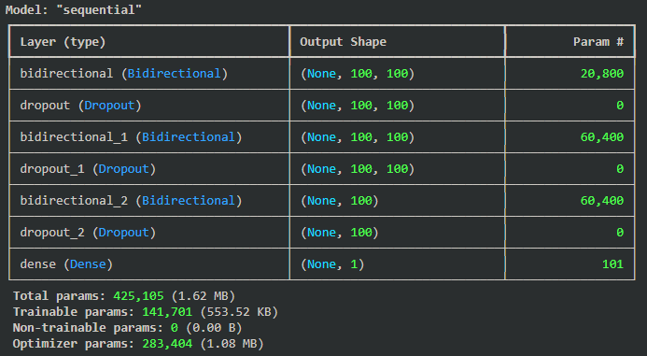
Figure 9: The above summary extracted from the code

Output Shapes:
The first Bidirectional LSTM layer generates a sequence with the form (None, 100, 100), where the batch size is represented by None, the sequence length by 100, and the number of units in the LSTM layer (50 units in each direction) by the final 100. The next Bidirectional LSTM layers keep this pattern going until the last Bidirectional LSTM layer, which fails to generate any sequences and lowers the output to (None, 100).
Parameters:
There are 425,105 parameters in the model in general, and every parameter is trainable, which means that it will update while it is being trained. Most of these parameters, which represent the intricacy and ability of the data-driven model for learning are found in the Bidirectional LSTM layers.
Training:
The fitting technique is then used to train the model on the dataset, with the training inputs and outputs, respectively, being X_train and y_train. On a different dataset (X_test, y_test) with a batch size of 32, the model is verified over 100 epochs. During the training phase, the Adam optimizer is used to minimize the loss function (mean_squared_error) by modifying the model weights in order to lower prediction errors.

4.8 Analysis of Model Predictions, Performance, and Generalization:
A predictive model's potential to generalize the new data should be evaluated in addition to its accuracy on training data in evaluating stock price prediction algorithms. Understanding the model's resilience and flexibility in predicting future stock prices, as well as assessing its performance on the training and test datasets, are all part of this process. A useful tool for well-informed decision-making in financial markets is a model that can reliably anticipate stock movements without overfitting, as demonstrated by its success in practical applications.
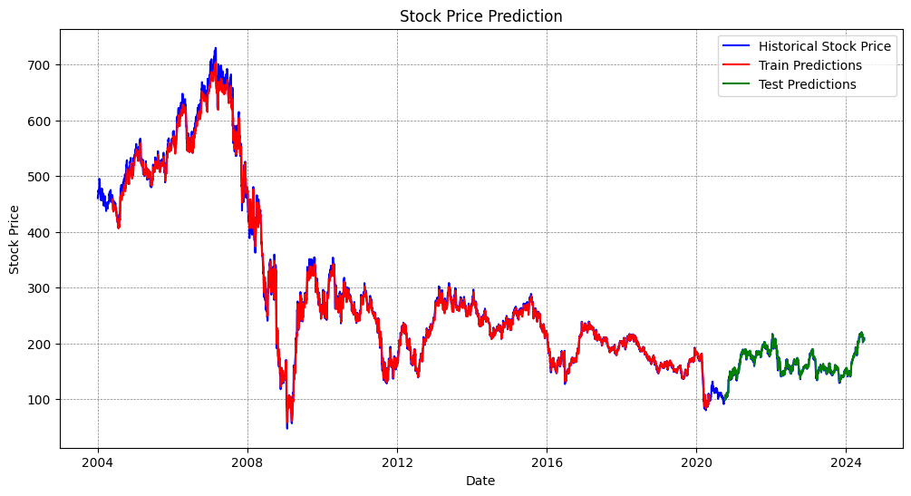
Figure 10: Test and Train Prediction
Train Predictions and Performance:
The model's predictions on the training dataset, indicated by the red line, closely align with the actual historical stock prices indicated by the blue line, particularly in the regions corresponding to the training set. This dataset includes the historical data the model was exposed to during training, allowing it to learn the patterns, trends, and oscillations inherent in stock price data. The tight alignment between the red and blue lines indicates that the model has effectively identified key patterns, successfully predicting stock values, especially during the early years up until 2020.
The RMSE (Root Mean Square Error) of 8.7354 suggests that the model is quite accurate, though it still exhibits a small margin of error, reflecting the inherent complexity and volatility of stock prices. Despite these minor deviations, the low RMSE demonstrates that the model's predictions are generally reliable, effectively capturing the underlying trends while accounting for the natural fluctuations in stock price actions.
Test Predictions and Performance:
The model's predictions on the test dataset, represented by the green line, indicate how well the model generalizes to new, unseen data. This dataset, consisting of historical stock prices not used during training, is crucial for evaluating the model's ability to forecast stock values it has never encountered before. During the test period (around 2020 onward), the green line closely aligns with the blue line, showing that the model has effectively learned to predict future prices based on the patterns identified during training.
The RMSE on the test data is 3.4410, significantly lower than the RMSE on the training data, highlighting the model's strong generalization capabilities. This lower RMSE suggests that the model is not only accurate but also robust, able to apply its learned knowledge to new data without overfitting a common issue where models perform well on training data but inadequately on test data due to learning overly complex patterns from noise. The model's ability to maintain a lower RMSE on the test set underscores its effectiveness and reliability in predicting real-world stock prices.
Robustness and Generalization of the Model:
A predictive model's generality and robustness are important factors to consider when assessing its efficacy. In this instance, a significant indication that the model is reliable and well-balanced is the fact that the RMSE on the test data is smaller than on the training data. A model that is less sensitive to the finer points or noise in the training data has effectively captured the basic patterns and trends in the actions of stock prices, as indicated by a reduced RMSE on test data. The reason this balance is important is that it indicates the model is not overfitting, which occurs when a model works well on training data but not on fresh, untested data.
An adaptable model is characterized by its effective generalization, which shows that the model can use its knowledge to apply itself and make correct predictions about future data. Because additional data that wasn't included in the initial training set will inevitably be encountered in real-world circumstances, this generalization makes sure the model stays trustworthy and valuable. Accurate forecasting in a variety of scenarios is the ultimate goal of these predictive models, and the model's ability to accomplish this goal is indicated by the reduced test RMSE. It suggests that the model has acquired the ability to apply its understanding of the fundamental dynamics of stock price fluctuations to fresh data, which makes it an invaluable resource for forecasting and decision-making in the ever-changing financial markets. Long-term forecasting and strategic planning depend on the model's ability to remain robust and adaptive, able to sustain its predictive power throughout a range of market situations and time periods, without overfitting to the training data.
4.9 Forecasting Future Stock Prices using LSTM Model:
Accurately projecting future movements of stock prices based on historical data is essential for making well-informed investing decisions. Comprehending intricate patterns and trends in stock prices is possible by utilizing sophisticated machine learning methods, like long short-term memory models. These models can produce accurate future projections by bending and scaling recent past data. This provides insightful information about possible market developments and increases investor confidence in projecting future price movements.
Reshaping and scaling the last 100 days of historical stock prices to update the LSTM model with new information. It then predicts one day at a time for the next 100 days, changing the input sequence with each new prediction and repeating the process. After that, the future projections are inversely inverted to restore the initial scale.

Figure 11: Stock Price Future Prediction using LSTM Model
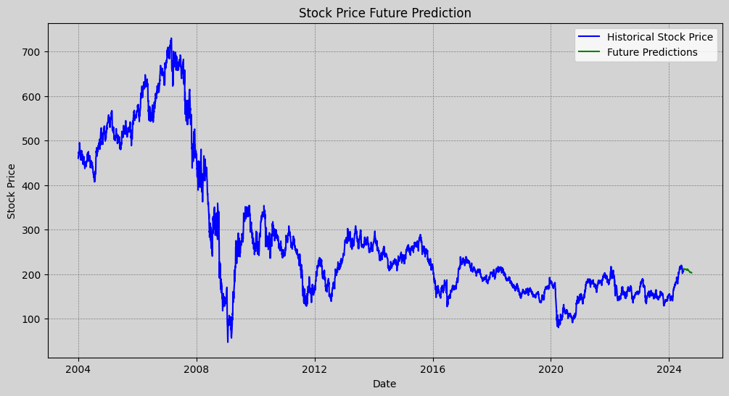
The blue line on the graph, which shows historical stock values from 2004 to 2024 and captures significant market events including the surge prior to 2008, the steep decrease during the financial crisis, and the recovery periods that followed, visually portrays these projections. The model's prediction for stock prices beyond historical data is shown by the green line. The fundamental patterns and trends in the stock prices appear to have been successfully learned by the model projecting these into the future with a modest upward tendency after 2024, based on the close alignment and effortless change between the historical data (blue line) and future predictions (green line).
This combination graphic, which projects possible future stock price movements based on historical performance, provides insightful information for analysts and investors. The model's efficacy and dependability as a tool for making wise investment decisions are highlighted by its capacity to extrapolate past trends into future projections. The methodology not only underscores the predictive power of the model but also illustrates its resilience in preserving consistency with past trends while forecasting future market fluctuations.
4.10 Prophet Model for Time Series Forecasting in Stock Price Analysis:
Facebook's Prophet model, which is especially well-suited for time series forecasting combining seasonality and trend components, is also used in parallel with the LSTM technique in this investigation. Using prophet, one can forecast future stock prices by identifying cyclical patterns and underlying trends in the data. The estimates for the next year are produced after the model has been trained using previous stock prices. The capacity of the model to anticipate future prices is then visually represented by plotting these forecasts alongside the actual historical data. Incorporating confidence intervals surrounding the Prophet forecasts enhances their usefulness by providing an illustration of the possible future stock price range, which facilitates risk assessment.
The Prophet model, a popular time series forecasting method, is used to forecast stock prices, as seen in the graph. The real historical stock prices from 2004 to 2024 are represented by the black dots; these represent key market moments like the surge prior to 2008, the steep decrease during the financial crisis, and the ensuing recovery phases. The Prophet model has successfully identified the underlying patterns and trends in the historical data, as seen by the blue line that reflects the model's forecast and closely reflects the progression of the observed data points.
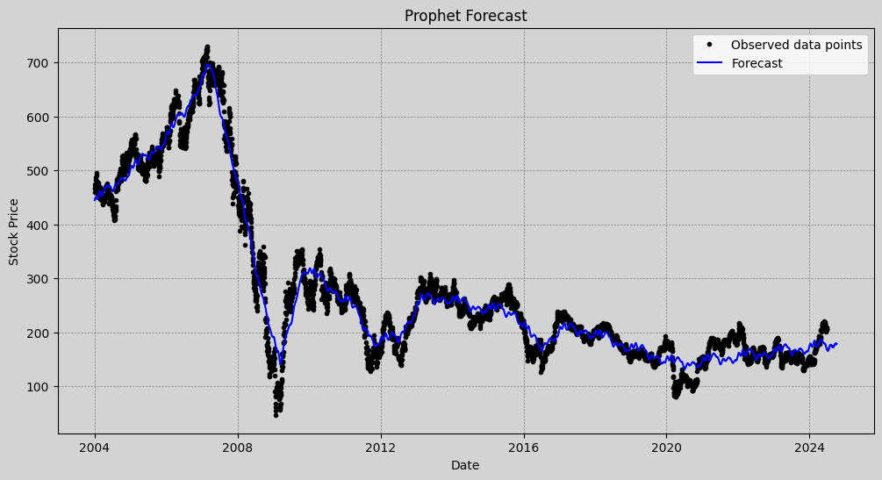
Figure 12: Stock Price Prediction using Prophet Model
The forecast line and the observed data points are closely aligned, indicating that the Prophet model accurately captures past stock price changes. This increases the predictability of the model's future forecasts. The blue line's smooth continuation outside of the observed data points shows how confident the model is in its ability to predict future trends from historical data. With the idea that similar patterns would persist into the future, the projection takes into account the cyclical character of the stock price, which includes periods of growth, decrease, and stabilization.
The Prophet model can learn from past data and project similar trends into the future, as this combination image shows, offering analysts and investors insightful information. The model is a helpful tool for determining probable future market movements since it can accurately match historical data and forecast future stock prices.
4.11 Comparison of Prophet and LSTM Models for Predicting Stock Prices:
Finally, a detailed analysis of the advantages and disadvantages of the LSTM and Prophet models is possible thanks to the comparison and visualization of their predictions. Because it is so good at capturing sequential dependencies and short-term variations, the LSTM model responds very well to recent changes in pricing. Prophet, on the other hand, provides a broader perspective of future price positions due to its capacity to model seasonality and long-term trends. The study obtains a more thorough knowledge of the stock's possible future actions by integrating the findings from both models. The use of two models not only increases the predictability of the results but also creates opportunities for future iterations that could improve the forecast accuracy even further through hybrid modeling or the addition of other elements like economic and market data (Ma et al., 2022).

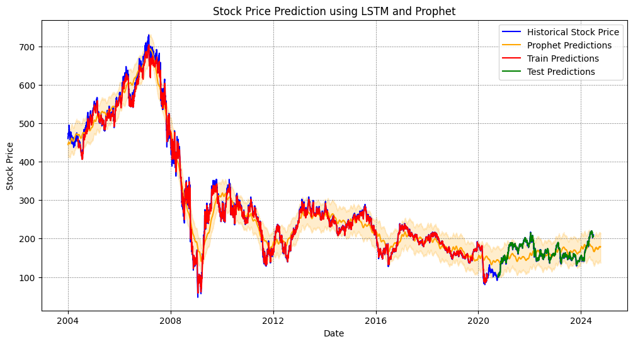
Figure 13: Comparison of Prophet and LSTM Models
The performance of the Prophet and LSTM models in predicting stock prices is shown in the graph. With a smoother curve and wider uncertainty bars, the orange line (Prophet) typically tracks past stock values, demonstrating its accuracy in projecting long-term trends. On the other hand, the red and green lines (LSTM) illustrate how well the model captures short-term patterns and generalizes to previously unseen data, offering a more accurate fit to the historical data, especially in the training and test regions.
The LSTM model excels in short-term predictions with closer alignment to historical prices, while the Prophet model offers a broader, smoothed prediction, capturing long-term trends and seasonality. This combination of models provides a comprehensive approach to stock price forecasting, where the LSTM model ensures short-term accuracy, and the Prophet model captures broader market trends. Together, they offer valuable insights for investors, enabling informed decisions based on both immediate fluctuations and long-term market movements.

5. Conclusion:
Finally, while both models have advantages, the comparative study of Long Short-Term Memory networks and the Prophet model for stock market prediction shows that the LSTM model performs better at capturing the short-term fluctuations and sequential dependencies present in stock price data. In the dynamic and volatile world of stock markets, the LSTM's architecture specifically, its capacity to manage long-term dependencies through recurrent connections enables it to adjust and improve forecasts over time, producing more accurate and reliable predictions.
On the other hand, the Prophet model offers a more comprehensive understanding of market movements by effectively incorporating seasonality and long-term trends. It is unable to precisely capture the complex and swift fluctuations in stock prices that the LSTM model is capable of handling.
The conclusion that the LSTM model is better trained for stock price prediction in this situation is further supported by the fact that the LSTM model's Root Mean Square Error is lower on both training and test datasets when compared to the Prophet model. Because of its high accuracy and good generalization to new data, it is a powerful tool for analysts and investors who want to forecast stock prices and make judgments based on current market conditions and trends.
6. Limitations:
While both Prophet and LSTM models have the potential to need large amounts of computing, LSTM is typically more taxing because of its complex architecture. Large amounts of time and computing resources are needed for training these models, which could prevent quick iteration and deployment especially in situations with limited resources. Furthermore, overfitting can occur in both models, particularly when training on data that does not accurately reflect overall market circumstances. The capacity of the model to generalize to new, unknown data is compromised by overfitting, which is a serious problem in the environment of the volatile stock market. Furthermore, because these models mostly employ historical data, they might not be able to adequately account for abrupt changes in the market brought on by outside variables like changes in geopolitical conditions, economic policies, or unexpected news, which could result in projections that are off during unstable market times.
7. Recommendation:
The integration of methods such dropout layers, regularization, and cross-validation in LSTM, as well as model architecture simplification or ensemble approaches, are suggested as ways to improve model generalization and overcome the shortcomings of Prophet and LSTM models in stock market prediction. One way to enhance the models' capacity to accommodate abrupt fluctuations and volatility in the market is by including external data sources like as macroeconomic indicators, geopolitical events, and news emotion. Even in contexts with limited resources, faster training and deployment are possible by managing the high computational demand and optimizing computational efficiency through early halting, model pruning, or the use of cloud computing resources. By putting these tactics into practice, LSTM and Prophet models for stock market forecasting can be used with much greater predictive accuracy, generalizability, and affordability.
8. References:

1. Abu-Mostafa, Y.S. & Atiya, A.F., 1996. Introduction to Financial Forecasting. Applied Intelligence, 6, pp. 205–213. DOI: 10.1007/BF00126626.
2. Alsuhaibani, M. & Kryzanowski, L., 2000. An exploratory analysis of the order book, and order flow and execution on the Saudi stock market. Journal of Banking & Finance, 24, pp. 1323-1357. DOI: 10.1016/S0378-4266(99)00075-8.
3. Barclays, n.d. About Barclays. Available at: https://home.barclays/who-we-are/our-history/ [Accessed 23 August 2024].
4. Barclays, n.d. Shareholders. Available at: https://home.barclays/investor-relations/shareholder-information/shareholder-forms/ [Accessed 23 August 2024].
5. Botunac, I., Panjkota, A. & Matetic, M., 2020. The Effect of Feature Selection on the Performance of Long Short-Term Memory Neural Network in Stock Market Predictions. Proceedings of the 31st DAAAM International Symposium, pp. 10.2507/31st.daaam.proceedings.081.
6. Chai, T. & Draxler, R.R., 2014. Root mean square error (RMSE) or mean absolute error (MAE)?– Arguments against avoiding RMSE in the literature. Geoscientific Model Development, 7, pp. 1247-1250. DOI: 10.5194/gmd-7-1247-2014.
7. Das, S.P. & Padhy, S., 2012. Support Vector Machines for Prediction of Futures Prices in Indian Stock Market. International Journal of Computer Applications, 41, pp. 22-26. DOI: 10.5120/5522-7555.
8. Dubey, S., Patil, N., Thakur, P. & Kanakia, H., 2022. Stock Market Prediction Using Yahoo finance and Twitter Polarity. 2022 IEEE 3rd Global Conference for Advancement in Technology (GCAT), Bangalore, India, pp. 1-5. DOI: 10.1109/GCAT55367.2022.9972013.
9. Ezepue, P., Urama, T. & Omar, M., 2019. Systematic Stock Market Characterisation and Development: Perspectives from Random Matrix Theory, Option Pricing, Genetics, and Global Economics. Journal of Mathematical Finance, 9, pp. 105-151. DOI: 10.4236/jmf.2019.92007.
10. Fama, E.F., 1965. Random Walks in Stock Market Prices. Financial Analysts Journal, 21(5), pp. 55–59. Available at: http://www.jstor.org/stable/4469865.
11. Facebook, 2017. Prophet: Forecasting at Scale. Available at: https://research.facebook.com/blog/2017/2/prophet-forecasting-at-scale/ [Accessed 23 August 2024].
12. Gandhi, R., Anand, G., Vekaria, V., Ahuja, T. & D’Mello, L., 2023. Stock Market Graph Prediction using LSTM. 2023 14th International Conference on Computing Communication and Networking Technologies (ICCCNT), Delhi, India, pp. 1-4. DOI: 10.1109/ICCCNT56998.2023.10306549.
13. Hamayel, M.J. & Owda, A.Y., 2021. A Novel Cryptocurrency Price Prediction Model Using GRU, LSTM and bi-LSTM Machine Learning Algorithms. AI, 2(4), pp. 477-496. DOI: 10.3390/ai2040030.
14. Hochreiter, S. & Schmidhuber, J., 1997. Long Short-Term Memory. Neural Computation, 9(8), pp. 1735-1780. DOI: 10.1162/neco.1997.9.8.1735.
15. Idrees, S.M., Alam, M.A. & Agarwal, P., 2019. A Prediction Approach for Stock Market Volatility Based on Time Series Data. IEEE Access, 7, pp. 17287-17298. DOI: 10.1109/ACCESS.2019.2895252.
16. Jancy, S., Ashok, V., Pavan, C.H., Priyadarshini, E., Mary, A.V.A.M. & Selvan, M.P., 2024. Stock market prediction using machine learning techniques. AIP Conference Proceedings, 2850(1), 030007. DOI: 10.1063/5.0208908.
17. Kaninde, S., Mahajan, M., Janghale, A. & Joshi, B., 2022. Stock Price Prediction using Facebook Prophet. ITM Web of Conferences, 44, 03060. DOI: 10.1051/itmconf/20224403060.
18. Khand, S., Anand, V. & Qureshi, M.N., 2020. The Predictability and Profitability of Simple Moving Averages and Trading Range Breakout Rules in the Pakistan Stock Market. Review of Pacific Basin Financial Markets and Policies, 23, 2050001. DOI: 10.1142/S0219091520500010.
19. Li, Z., Yu, H., Xu, J., Liu, J. & Mo, Y., 2023. Stock Market Analysis and Prediction Using LSTM: A Case Study on Technology Stocks. Innovations in Applied Engineering and Technology, 2(1), pp. 1-6. DOI: 10.62836/iaet.v2i1.162.
20. Lu, Y., Sheng, B., Fu, G., Luo, R., Chen, G. & Huang, Y., 2023. Prophet-EEMD-LSTM based method for predicting energy consumption in the paint workshop. Applied Soft Computing, 143, 110447.
21. Ma, C., Yan, C., Suo, Q. & Liu, C., 2022. Meteorological data combination prediction model based on Prophet + LSTM. 2022 IEEE 6th Information Technology and Mechatronics Engineering Conference (ITOEC), Chongqing, China, pp. 699-705. DOI: 10.1109/ITOEC53115.2022.9734561.
22. Nabipour, M., Nayyeri, P., Jabani, H.S. & Mosavi, A., 2020. Predicting Stock Market Trends Using Machine Learning and Deep Learning Algorithms Via Continuous and Binary Data; a Comparative Analysis. IEEE Access, 8, pp. 150199-150212. DOI: 10.1109/ACCESS.2020.3015966.
23. Nair, A.V. & Narayanan, J., 2022. Indian Stock Market Forecasting using Prophet Model. 2022 International Conference on Connected Systems & Intelligence (CSI), Trivandrum, India, pp. 1-7. DOI: 10.1109/CSI54720.2022.9924117.
24. Patwal, P.S. & Srivastava, A.K., 2023. Proposed Model for Prediction of Stock Market Price of Netflix. 2023 International Conference on Artificial Intelligence and Applications (ICAIA) Alliance Technology Conference (ATCON-1), Bangalore, India, pp. 1-5. DOI: 10.1109/ICAIA57370.2023.10169347.
25. Peng, Z.-Y. & Guo, P.-C., 2022. A Data Organization Method for LSTM and Transformer When Predicting Chinese Banking Stock Prices. Discrete Dynamics in Nature and Society, 2022. Available at: http://dx.doi.org.ezproxy.herts.ac.uk/10.1155/2022/7119678.
26. Raubitzek, S. & Neubauer, T., 2022. An Exploratory Study on the Complexity and Machine Learning Predictability of Stock Market Data. Entropy, 24(3), 332. DOI: 10.3390/e24030332.
27. Rumelhart, D.E., Hinton, G.E. & Williams, R.J., 1986. Learning representations by back-propagating errors. Nature, 323, pp. 533-536.
28. Satrio, C.B.A., Darmawan, W., Nadia, B.U. & Hanafiah, N., 2021. Time series analysis and forecasting of coronavirus disease in Indonesia using ARIMA model and PROPHET. Procedia Computer Science, 179, pp. 524-532.
29. Schuster, M. & Paliwal, K.K., 1997. Bidirectional recurrent neural networks. IEEE Transactions on Signal Processing, 45(11), pp. 2673-2681. DOI: 10.1109/78.650093.
30. Tiwari, S., Cheng, J., Djebbouri, K., Mahendru, M. & Shahzad, U., 2023. Forecasting Bitcoin prices using artificial intelligence: Combination of ML, SARIMA, and Facebook Prophet models. Technological Forecasting and Social Change, 198. DOI: 10.1016/j.techfore.2023.122938.
31. Wang, W. & Lu, Y., 2018. The Effect of Feature Selection on the Performance of Long Short-Therm Memory Neural Network in Stock Market Predictions. IOP Conference Series: Materials Science and Engineering, 324, 012049. DOI: 10.1088/1757-899X/324/1/012049.
32. Yan, S., n.d. Understanding LSTM and Its Diagrams. Available at: https://medium.com/mlreview/understanding-lstm-and-its-diagrams-37e2f46f1714 [Accessed 23 August 2024].
33. Yildirim, Ö., 2018. A novel wavelet sequence based on deep bidirectional LSTM network model for ECG signal classification. Computers in Biology and Medicine, 96, pp. 10.1016/j.compbiomed.2018.03.016.
9.Appendices:

**Import necessary libraries for data processing, visualization, and model building**
"""
# Import necessary libraries
import numpy as np
import pandas as pd
import matplotlib.pyplot as plt
from matplotlib import style
import yfinance as yf
import tensorflow as tf
from sklearn.preprocessing import MinMaxScaler
from keras.layers import Dense, Dropout, LSTM, Bidirectional
from keras.models import Sequential
import datetime, math
from datetime import date, timedelta
from keras.utils import plot_model
from sklearn.metrics import mean_squared_error
from tensorflow.keras.utils import set_random_seed
from tensorflow.keras import losses, optimizers
from sklearn.impute import SimpleImputer
from keras.utils import plot_model
import matplotlib.pyplot as plt
from prophet import Prophet

"""**Set random seed for reproducibility of results**"""

# Fixing the random seed for reproducibility
np.random.seed(42)
tf.random.set_seed(42)
set_random_seed(42)

"""**Load historical stock data using yfinance for a specified ticker symbol**"""

#Loading Data
ticker = "BARC.L"
data = yf.download(ticker, start="2004-01-01", end="2024-06-28")

"""**Display the raw stock data**"""

data

"""**Clean the data by resetting the index, removing any rows with missing values, and imputation**"""

#Data Cleaning
data.reset_index(inplace=True)
data.dropna(inplace=True)

#Handling missing values in a more robust way
imputer = SimpleImputer(strategy='mean')
data['Close'] = imputer.fit_transform(data[['Close']])

"""**Display the cleaned stock data**"""

data

"""**Display a summary of the DataFrame's structure and data types**"""

data.info()

"""**Plot the closing price of Barclays stock**"""

plt.figure(figsize=(12, 6))

# Plotting the closing price
plt.plot(data["Date"], data["Close"], label='Close Price', color='blue')
plt.title("Barclays Stock Price Analysis")
plt.xlabel("Date")
plt.ylabel("Price")
plt.grid(True, which='both', linestyle='--', linewidth=0.5, color='gray')
plt.gca().set_facecolor('lightgray') # Plot background
plt.gcf().set_facecolor('lightgray') # Figure background
plt.legend()
plt.show()

"""**Calculate and plot the 100-day and 200-day moving averages of the 'Close' prices, along with the original closing prices, to analyze the stock's long-term trends**

"""

#Calculating and plotting the 100-day and 200-day moving average of the 'Close' prices
data['SMA_100'] = data['Close'].rolling(window=100).mean() # 100-day Simple Moving Average
data['SMA_200'] = data['Close'].rolling(window=200).mean() # 200-day Simple Moving Average

plt.figure(figsize=(12,6))
plt.plot(data["Date"], data["Close"], label='Close Price', color='skyblue')
plt.plot(data["Date"], data['SMA_100'], label='100-day SMA',linestyle='--', color='g')
plt.plot(data["Date"], data['SMA_200'], label='200-day SMA',linestyle='--', color='r')
plt.title("100-day and 200-day moving average of the 'Close' prices")
plt.xlabel("Date")
plt.ylabel("Stock Price")
plt.grid(True, which='both', linestyle='--', linewidth=0.5, color='gray')
plt.gca().set_facecolor('lightgray')
plt.gcf().set_facecolor('lightgray')
plt.legend()
plt.show()

"""**Split the data into training and test sets to scale the data between 0 and 1 and create sequences for LSTM model training**

"""

# Splitting Data
data_train = pd.DataFrame(data.Close[0: int(len(data)*0.80)])
data_test = pd.DataFrame(data.Close[int(len(data)*0.80): len(data)])

#Scaling Data
scaler = MinMaxScaler(feature_range=(0,1))
data_train_scale = scaler.fit_transform(data_train)
data_test_scale = scaler.transform(data_test)

# Creating Training Sequences
def create_sequences(data, time_step=1):
X, Y = [], []
for i in range(len(data)-time_step-1):
a = data[i:(i+time_step), 0]
X.append(a)
Y.append(data[i + time_step, 0])
return np.array(X), np.array(Y)

"""**Generate training and test sequences with a specified time step, and reshape the input data for LSTM model compatibility**"""

time_step = 100
X_train, y_train = create_sequences(data_train_scale, time_step)
X_test, y_test = create_sequences(data_test_scale, time_step)

# Reshape input to be samples, time steps, features which is required for LSTM
X_train = X_train.reshape(X_train.shape[0],X_train.shape[1] , 1)
X_test = X_test.reshape(X_test.shape[0],X_test.shape[1] , 1)

"""**Build and compile a bidirectional LSTM model with dropout layers for regularization, and fit it to the training data with validation**"""

# Building the LSTM Model
lstm_model = Sequential()
lstm_model.add(Bidirectional(LSTM(50, return_sequences=True, input_shape=(time_step, 1))))
lstm_model.add(Dropout(0.2))
lstm_model.add(Bidirectional(LSTM(50, return_sequences=True)))
lstm_model.add(Dropout(0.2))
lstm_model.add(Bidirectional(LSTM(50)))
lstm_model.add(Dropout(0.2))
lstm_model.add(Dense(1))
lstm_model.compile(loss='mean_squared_error', optimizer='adam')

# Fitting the model to the training data with validation data
history = lstm_model.fit(X_train, y_train, validation_data=(X_test, y_test), epochs=100, batch_size=32, verbose=1)

"""**Plot the training and validation loss over epochs to evaluate the model's performance during training**

"""

# Plot training loss and validation loss
plt.figure(figsize=(12, 6))
plt.plot(history.history['loss'], label='Training Loss')
plt.plot(history.history['val_loss'], label='Validation Loss')
plt.title('Training and Validation Loss')
plt.xlabel('Epochs')
plt.ylabel('Loss')
plt.legend()
plt.grid(True, which='both', linestyle='--', linewidth=0.5, color='gray')
plt.gca().set_facecolor('lightgray')
plt.gcf().set_facecolor('lightgray')
plt.show()

"""**Display a summary of the LSTM model's architecture, including the layers and parameters**"""

#Summarizing the Model architecture
lstm_model.summary()

"""**Generate a visual plot of the LSTM model architecture, displaying layer names and shapes**"""

plot_model(lstm_model, to_file='model_plot.png', show_shapes=True, show_layer_names=True)

"""**Predict on the training and test data, inverse transform the predictions to the original scale and calculate the RMSE for both datasets**"""

# Predicting on the Test Data
train_predict = lstm_model.predict(X_train)
test_predict = lstm_model.predict(X_test)

# Inverse Transforming the Predictions and Actual Values to Original Scale
train_predict = scaler.inverse_transform(train_predict)
test_predict = scaler.inverse_transform(test_predict)
y_train = scaler.inverse_transform(y_train.reshape(-1, 1))
y_test = scaler.inverse_transform(y_test.reshape(-1, 1))

# Calculate RMSE
rmse_train = np.sqrt(mean_squared_error(y_train, train_predict))
rmse_test = np.sqrt(mean_squared_error(y_test, test_predict))
print(f'RMSE on Training Data: {rmse_train}')
print(f'RMSE on Test Data: {rmse_test}')

"""**Plot the LSTM model's training and test predictions to visualize the model's performance**"""

# Plotting the Predictions and Actual Values
plt.figure(figsize=(14,7))
plt.plot(data['Date'], data['Close'], label='Historical Stock Price', color='blue')
plt.plot(data['Date'][time_step:len(train_predict)+time_step], train_predict, label='Train Predictions', color='red')
plt.plot(data['Date'][len(train_predict)+(time_step*2)+1:len(data)-1], test_predict, label='Test Predictions', color='green')
plt.title('Stock Price Prediction')
plt.xlabel('Date')
plt.ylabel('Stock Price')
plt.legend()
plt.grid(True, which='both', linestyle='--', linewidth=0.5, color='gray')
plt.show()

"""**Predict future stock prices for the next 100 days using the LSTM model, and plot both historical data and future predictions**

"""

# Future Prediction Code
# Ensure correct scaling and transformation of the last 100 days
last_100_days = data['Close'].values[-100:].reshape(-1, 1)
last_100_days_scaled = scaler.transform(last_100_days)

# Ensure correct shape of the input data
current_input = last_100_days_scaled.reshape(1, last_100_days_scaled.shape[0], last_100_days_scaled.shape[1])

# Number of future days to predict
future_days = 100

# Generating future predictions
future_predictions = []

for _ in range(future_days):
future_pred = lstm_model.predict(current_input)
future_predictions.append(future_pred[0, 0])
current_input = np.append(current_input[:, 1:, :], future_pred.reshape(1, 1, 1), axis=1)

# Inverse transform the future predictions
future_predictions = scaler.inverse_transform(np.array(future_predictions).reshape(-1, 1))

# Generate future dates
last_date = data['Date'].iloc[-1]
future_dates = pd.date_range(last_date + timedelta(1), periods=future_days).tolist()

# Plotting the future predictions
plt.figure(figsize=(14, 7))
plt.plot(data['Date'], data['Close'], color='blue', label='Historical Stock Price')
plt.plot(future_dates, future_predictions, color='green', label='Future Predictions')
plt.title('Stock Price Future Prediction')
plt.xlabel('Date')
plt.ylabel('Stock Price')
plt.legend()
plt.grid(True, which='both', linestyle='--', linewidth=0.5, color='gray')
plt.gca().set_facecolor('lightgray')
plt.gcf().set_facecolor('lightgray')
plt.show()

"""**Prepare data for the Prophet model and fit the model to make future predictions and calculate the RMSE on the historical data**"""

# Prepare the data for Prophet
prophet_data = data[['Date', 'Close']]
prophet_data.columns = ['ds', 'y']

# Initialize and fit the Prophet model
prophet_model = Prophet(daily_seasonality=True)
prophet_model.fit(prophet_data)

# Make future predictions
future = prophet_model.make_future_dataframe(periods=future_days)
forecast = prophet_model.predict(future)

# Extract the historical predictions
historical_forecast = forecast[forecast['ds'].isin(prophet_data['ds'])]

# Calculate RMSE
rmse = np.sqrt(mean_squared_error(prophet_data['y'], historical_forecast['yhat']))
print(f'RMSE: {rmse}')

"""**Plot the observed data points along with the Prophet model's forecast to visualize the predictions**"""

# Plotting the Prophet predictions
plt.figure(figsize=(14, 7))
plt.plot(prophet_data['ds'], prophet_data['y'], 'k.', label='Observed data points')
plt.plot(forecast['ds'], forecast['yhat'], 'b-', label='Forecast')
plt.title('Prophet Forecast')
plt.xlabel('Date')
plt.ylabel('Stock Price')
plt.legend()
plt.grid(True, which='both', linestyle='--', linewidth=0.5, color='gray')
plt.gca().set_facecolor('lightgray')
plt.gcf().set_facecolor('lightgray')
plt.show()

"""**Combine and plot the LSTM and Prophet model predictions along with historical stock prices for comparison**"""

# Combine LSTM and Prophet predictions
plt.figure(figsize=(14, 7))
plt.plot(data['Date'], data['Close'], color='blue', label='Historical Stock Price')
plt.plot(forecast['ds'], forecast['yhat'], color='orange', label='Prophet Predictions')
plt.fill_between(forecast['ds'], forecast['yhat_lower'], forecast['yhat_upper'], color='orange', alpha=0.2)
plt.plot(data['Date'][time_step:len(train_predict)+time_step], train_predict, color='red', label='Train Predictions')
plt.plot(data['Date'][len(train_predict)+(time_step*2)+1:len(data)-1], test_predict, color='green', label='Test Predictions')
plt.title('Stock Price Prediction using LSTM and Prophet')
plt.xlabel('Date')
plt.ylabel('Stock Price')
plt.legend()
plt.grid(True, which='both', linestyle='--', linewidth=0.5, color='gray')
plt.show()

"""**Create and display a DataFrame comparing the actual and predicted closing prices on the test set**"""

# Print the prediction and the actual close value for comparison
comparison_df = pd.DataFrame({
'Date': data['Date'][len(data_train):len(data_train) + len(y_test)],
'Actual': y_test.flatten(),
'Predicted': test_predict.flatten()
})

comparison_df

